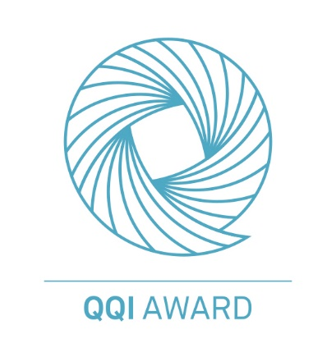

# Assessment brief: 6 Personal Statement

|  |  |
| --- | --- |
| **Module Title:** **Work Experience/Personal and Professional Development** | **Code:**  **5N2985** |
| **Tutor:** **Milica Traljic** | **Weighting:**  **Personal & Professional Dev 8%** |
| **Issue Date: As per Moodle** | **Due Date: As per Moodle** |

**Learning Outcomes Covered:**

Personal and Professional Development LO1, LO4, LO6 and LO7.

**Assessment Criteria:**

|  |  |
| --- | --- |
| **Personal and Professional Development** | |
| **Topic** | **Marks** |
|  | |
| Write Personal Statement for UCAS | **8** |

**Plagiarism Declaration:**

I declare that this material, which I now submit for assessment, is entirely my own work and has not been taken from the work of others, save and to the extent that such work has been cited and acknowledged within the text of my work. This assignment, or any part of it, has not been previously submitted by me or any other person for assessment on this or any other course of study.

I understand that plagiarism, collusion, and copying is a grave and serious offence in LMETB, and I accept the penalties that may be imposed should I engage in plagiarism, collusion, or copying.

I pledge to be fair and honest to other learners and to my tutor by completing all of my academic work with integrity. This means that I will respect the standards set by my tutor and LMETB, be responsible for the consequences of my choices, honestly represent my knowledge and abilities, and be a community member that others can trust.

**Candidate’s signature: Scott Fowler** ________________________________________

**Date: 22/03/25** ________________________________________

Please include a personal statement used to apply for a college place, if you don’t have one, please create one. There is a video below on writing a personal statement to help. (8 marks)

<https://www.ucas.com/undergraduate/applying-university/how-write-ucas-undergraduate-personal-statement>

Word Count – 500 – 800 words

1. Preparation and research of your chosen course.

1. Motivation/Evidence of commitment to the course.

1. What makes you suitable for your chosen course.

1. Future personal and professional goals.

1. Conclusion/Additional information.

|  |
| --- |
| Since I started playing video games at a young age, I got interested with game design very early on. I started off with Scratch, making small projects while also learning 3D modelling with software such as Blender. This interest evolved as I got into secondary level education, where I furthered my knowledge in my personal time. I learnt new programming languages, created my own video games, and released one to the public. This first game I released is called DwarVein and is available on the Google Play Store. Some of the challenges I overcame with this project include playtesting and bringing the project to a final state that is presentable to the public. It also taught me the importance of marketing alongside the creation of my game.  This interest has only been reinforced with my current education within Dunboyne College, where I have strengthened my skills and diversified myself with projects from web development, game development and application development, often designing both the frontend and backend. Examples include my personal portfolio which utilizes a database for information alongside utilising my API to allow updates from my mobile application, and my documented game project known as Blindside which I created and released on Itch.io within a month.  During my time within Dunboyne College, I have excelled at the work I was assigned. I brought several game projects to life such as Blindside and another known as Scalar Trajectory while also aiding my colleagues in their developments. When working as a team, I ensured everyone had their say in what was included, and that their voices were heard. I also pursued my personal goals through the assignments I was tasked with. Implementing extra features on projects when there was extra time, ensuring they were presentable at a future date.  My motivation to design games is not held in the lecture halls alone, when I return home I continue to study and unravel anything I do not understand, furthering my own personal projects and ensuring assignments are completed on time. Due to this level of motivation, I am confident that it will ensure I succeed as a professional Game Designer.  As I am interested in bringing ideas to life through the creation of games, I find the role perfectly suitable as it requires the knowledge and understanding of all aspects of a game. From level design to world building, to game mechanics and programming. I know that becoming a professional Game Designer will aid in where I want to go.  Professional experiences in the field include an Indie Game Studio that I held work experience with named Sleepless, which I was kept a part of after my experience was complete. With the Team I learnt Level Design and furthered my capability at working as a team. I have also gone to several workshops ran by Imirt, the Irish Game Developers Association to aid in expanding my understanding & knowledge of Game Design. I have also Self Published my own game to the Google Play Store with moderate success. This was a project created solely by myself.  Where I aim to be in the future is leading my own indie studio, creating games of which are unique experiences that players can share together. Learning how to lead a team, and how each of the intricate parts of Game Development intertwine are key to my success and I am highly motivated to see it through. Following my early interests in game design I want to use my motivation to achieve my goals. From furthering developments as a team, to learning more about each skill required to bring a game idea to life. Becoming a Game Designer will help in the direction I am going. |